

Six weeks industrial training report

(5th semester)

On

___________________________________________________

**AUTOMATED TELLER MACHINE** ___________________________________________________

Submitted for the partial fulfilment of degree

Of

Bachelor of Technology

(Computer Science of Technology)

Submitted by: Submitted to:

Mohammad Shahid Mrs.Priyanka

University rollno:- 2129686

**DECLARATION**

I,Mohammad Shahid, student of B.Tech (computer science enginnering) 5th semester,studying at Chandigarh Engineering College Jhanjeri , hereby declare that the six week Industrial training Report,undergone at "SOLITAIRE INFOSYS", submitted to Chandigarh Engineering College , inpartial fullfilment of the award of degree of Bachelor of Technology in Computer science Enginnering is the original work conducted by me.

The information and the data in the report is authentic to the best of my knowledge.

**Mohammad Shahid**

**ACKNOWLEDGEMENT**

I, student of Chandigarh Engineering College Jhanjeri, have taken efforts in this project. However, it would not have been possible without the kind support and help of many individuals and organizations. I would like to extend my sincere thanks to all of them. I am highly indebted to the “SOLITAIRE INFOSYS” for their guidance and constant supervision as well as for providing necessary information regarding the project and also for their support in completing the project. I would like to express my gratitude towards my teachers for their kind co-operation and encouragement which help me in completion of this project.

**Mohammad Shahid**

**Certificate**

**TABLE OF CONTENTS**

**Introduction :--**

**Technology used**

1. Front End , Back End

2. Frame Work

3. Code Editor

**Tkinter**

1. What is tkinter?
2. Tkinter first step
3. Tkinter Building Blocks
4. Tkinter Layout

**Python**

1. Intro

2. Why to learn python

3. Characteristics of python

4. Application of python

**Tkinter Framework**

**Vs Code**

**Source Code**

1. Main.py
2. Picture.py

**Conclusion**

**INTRODUCTION**

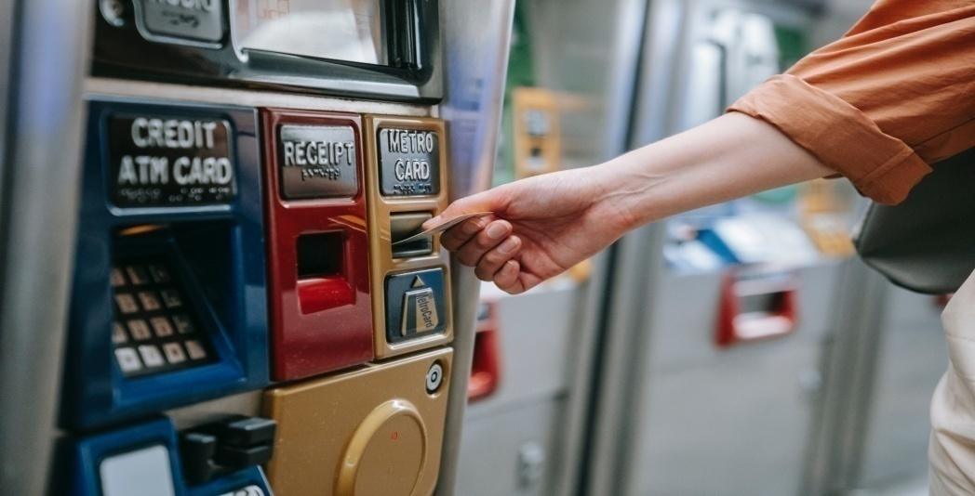

**What is Automated Teller Machine?**

ATM stands for Automated Teller Machine which is a self-service banking outlet. You can withdraw money, check your balance, or even transfer funds at an ATM. Different banks provide their ATM services by installing cash machines in different parts of the country. You can withdraw money from any of these machines irrespective of whether or not you are an account holder in the same bank.

ATM transactions are either free or bear a nominal charge depending upon the banks. Banks usually do not charge for the first 3-5 ATM transactions in a month. Once you cross the limit of free transactions, you may have to pay a nominal charge. Also, some banks levy charges if you withdraw money from the ATM of another bank of which you are not an account holder.

**Types of Automated Teller Machines (ATMs)**

Automated Teller Machines (ATMs) are mainly of two types. One is a simple basic unit that allows you to withdraw cash, check your balance, change the PIN, get mini statements and receive account updates. The more complex units provide facilities for cash or cheque deposits and line of credit &[bill payments](https://paytm.com/blog/bill-payments/electricity-bill-payment-online/).

**Technologies Used**

**Front End:**

**Python**

**Backend End:**

**Python**

**Framework:**

**Tkinter**

**Code editor:**

**VS code**

**PYTHON**

Python is a general-purpose interpreted, interactive, object-oriented, and high-level programming language. It was created by Guido van Rossum during 1985- 1990. Like Perl, Python source code is also available under the GNU General Public License (GPL). This tutorial gives enough understanding on Python programming language.

**Why to Learn Python ?**

Python is a high-level, interpreted, interactive and object-oriented scripting language. Python is designed to be highly readable. It uses English keywords frequently where as other languages use punctuation, and it has fewer syntactical constructions than other languages. Python is a MUST for students and working professionals to become a great Software Engineer specially when they are working in Web Development Domain.

**I will list down some of the key advantages of learning Python:**

• Python is Interpreted − Python is processed at runtime by the interpreter. You do not need to compile your program before executing it. This is similar to PERL and PHP.

• Python is Interactive − You can actually sit at a Python prompt and interact with the interpreter directly to write your programs.

• Python is Object-Oriented − Python supports Object-Oriented style or technique of programming that encapsulates code within objects.

• Python is a Beginner's Language − Python is a great language for the beginner-level programmers and supports the development of a wide range of applications from simple text processing to WWW browsers to games. Characteristics of Python Following are important

**Characteristics of Python Programming –**

• It supports functional and structured programming methods as well as OOP.

• It can be used as a scripting language or can be compiled to byte-code for building large applications.

• It provides very high-level dynamic data types and supports dynamic type checking.

• It supports automatic garbage collection. • It can be easily integrated with C, C++, COM, ActiveX, CORBA, and Java. Applications of Python As mentioned before, Python is one of the most widely used language over the web. I'm going to list few of them here:

• Easy-to-learn − Python has few keywords, simple structure, and a clearly defined syntax. This allows the student to pick up the language quickly.

• Easy-to-read − Python code is more clearly defined and visible to the eyes.

• Easy-to-maintain − Python's source code is fairly easy-to-maintain.

• A broad standard library − Python's bulk of the library is very portable and cross-platform compatible on UNIX, Windows, and Macintosh.

• Interactive Mode − Python has support for an interactive mode which allows interactive testing and debugging of snippets of code.

• Portable − Python can run on a wide variety of hardware platforms and has the same interface on all platforms.

• Extendable − You can add low-level modules to the Python interpreter. These modules enable programmers to add to or customize their tools to be more efficient.

• Databases − Python provides interfaces to all major commercial databases.

• GUI Programming − Python supports GUI applications that can be created and ported to many system calls, libraries and windows systems, such as Windows MFC, Macintosh, and the X Window system of Unix.

• Scalable − Python provides a better structure and support for large programs than shell scripting.

**Tkinter (Framework)**

Tkinter is the inbuilt python module that is used to create GUI applications. It is one of the most commonly used modules for creating GUI applications in Python as it is simple and easy to work with. You don’t need to worry about the installation of the Tkinter module separately as it comes with Python already. It gives an object-oriented interface to the Tk GUI toolkit. Some other Python Libraries available for creating our own GUI applications are

➢ Kivy

➢ Python Qt

➢ wxPython

Among all Tkinter is most widely used

**Here are some common use cases for Tkinter:**

**o Creating windows and dialog boxes:** Tkinter can be used to create windows and dialog boxes that allow users to interact with your program. These can be used to display information, gather input, or present options to the user.

**o Building a GUI for a desktop application:** Tkinter can be used to create the interface for a desktop application, including buttons, menus, and other interactive elements.

**o Adding a GUI to a command-line program:** Tkinter can be used to add a GUI to a command-line program, making it easier for users to interact with the program and input arguments.

**o Creating custom widgets:** Tkinter includes a variety of built-in widgets, such as buttons, labels, and text boxes, but it also allows you to create your own custom widgets.

**o Prototyping a GUI**: Tkinter can be used to quickly prototype a GUI, allowing you to test and iterate on different design ideas before committing to a final implementation.where it is vulnerable (instead cookies just contain a key, and the actual data is stored in the database) or directly storing passwords rather than a password hash.

**Basic Tkinter Widgets:**

**Widgets Description**

**Label :** It is used to display text or image on the screen

**Button :** It is used to add buttons to your application

**Canvas :** It is used to draw pictures and others layouts like texts, graphics etc.

**ComboBox:** It contains a down arrow to select from list of available options

**CheckButton**: It displays a number of options to the user as toggle buttons from which user can select any number of options.

**RadioButton:** It is used to implement one-of-many selection as it allows only one option to be selected Entry It is used to input single line text entry from user

**Frame:** It is used as container to hold and organize the widgets

**Message:** It works same as that of label and refers to multi-line and noneditable text

**Scale:** It is used to provide a graphical slider which allows to select any value from that scale

**Scrollbar:** It is used to scroll down the contents. It provides a slide controller.

**SpinBox:** It is allows user to select from given set of values Python

**How Popular Is Tkinter?**

Tkinter is the most preferred package used for creating nice GUIs for applications as it has a variety of methods like pack(), grid(), and place() for geometry management. It has standard attributed dimensions, fonts, colors, cursors, anchors, and bitmaps for a better GUI. Moreover, it has a vast array of widgets to choose from and is by far the easiest to use. The combination of all these features makes Python Tkinter makes it very popular among Python developers and makes it a good tool to use..

**VS CODE**

Visual Studio Code (famously known as VS Code) is a free open source text editor by Microsoft. VS Code is available for Windows, Linux, and macOS. Although the editor is relatively lightweight, it includes some powerful features that have made VS Code one of the most popular development environment tools in recent times.

**Features**  -

VS Code supports a wide array of programming languages from Java, C++, and Python to CSS, Go, and Dockerfile. Moreover, VS Code allows you to add on and even creating new extensions including code linters, debuggers, and cloud and web development support.

The VS Code user interface allows for a lot of interaction compared to other text editors. To simplify user experience,

**VS Code is divided into five main regions:**

• The activity bar

• The side bar

• Editor groups

• The panel

• The status bar The image below shows how these regions are displayed:

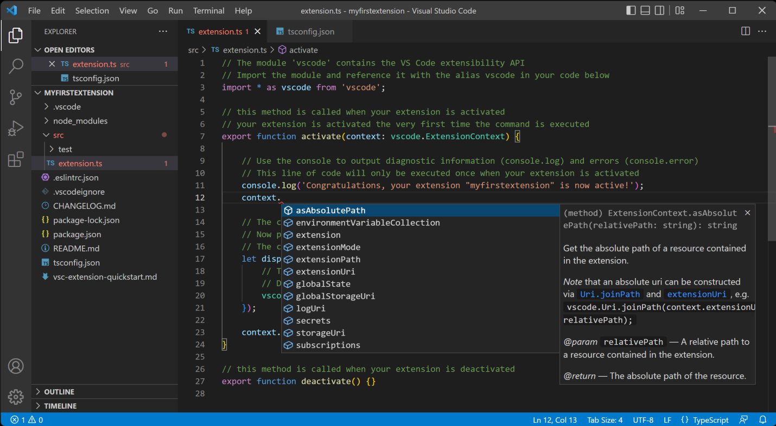

**Getting started -**

You can install the latest version of Visual Studio Code from their official website.

https://code.visualstudio.com

After installation, you can run the editor by entering the code -n command into the terminal. This will prompt VS Code to start and display a fresh instance. If you want to continue working from where you left off in the previous coding session, enter the code command without the -n flag. If you want to open VS Code in a certain directory, navigate to the directory and enter the code -r command. You are now on your way to writing powerful code on your VS Code environment!

**Source Code**

**Impoting Tkinter-**

1.png

**Making class-**

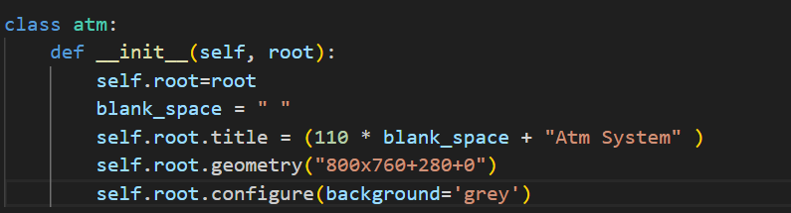

**Defining Frames-**

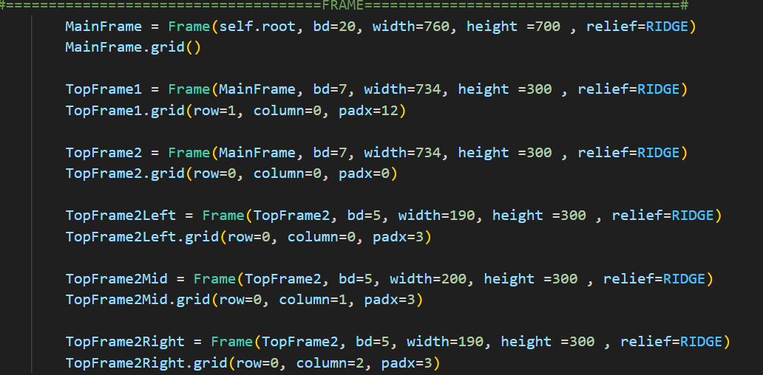

**Defining Functions-**

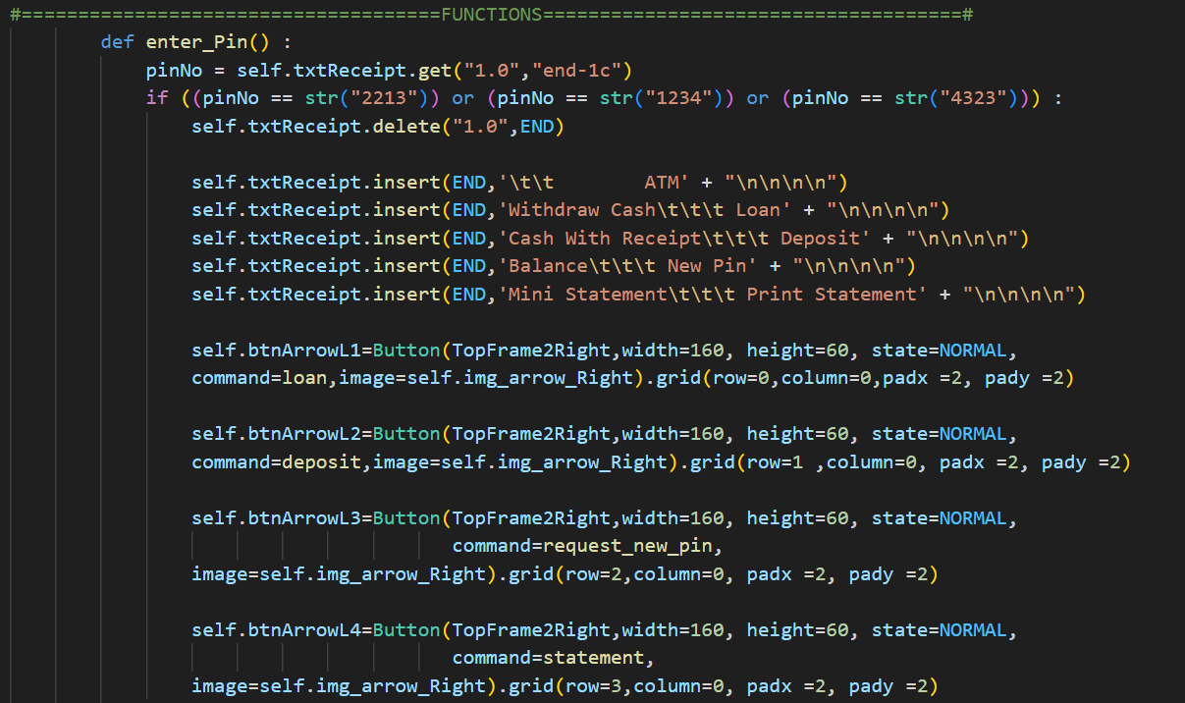

**Defining Widgets-**

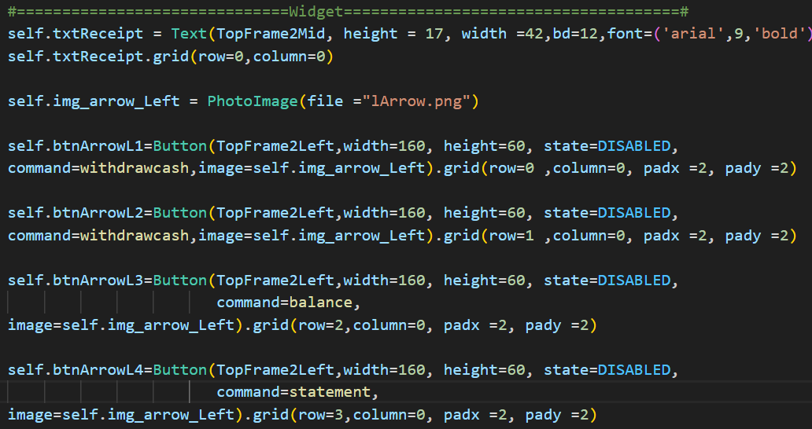

**Buttons-**

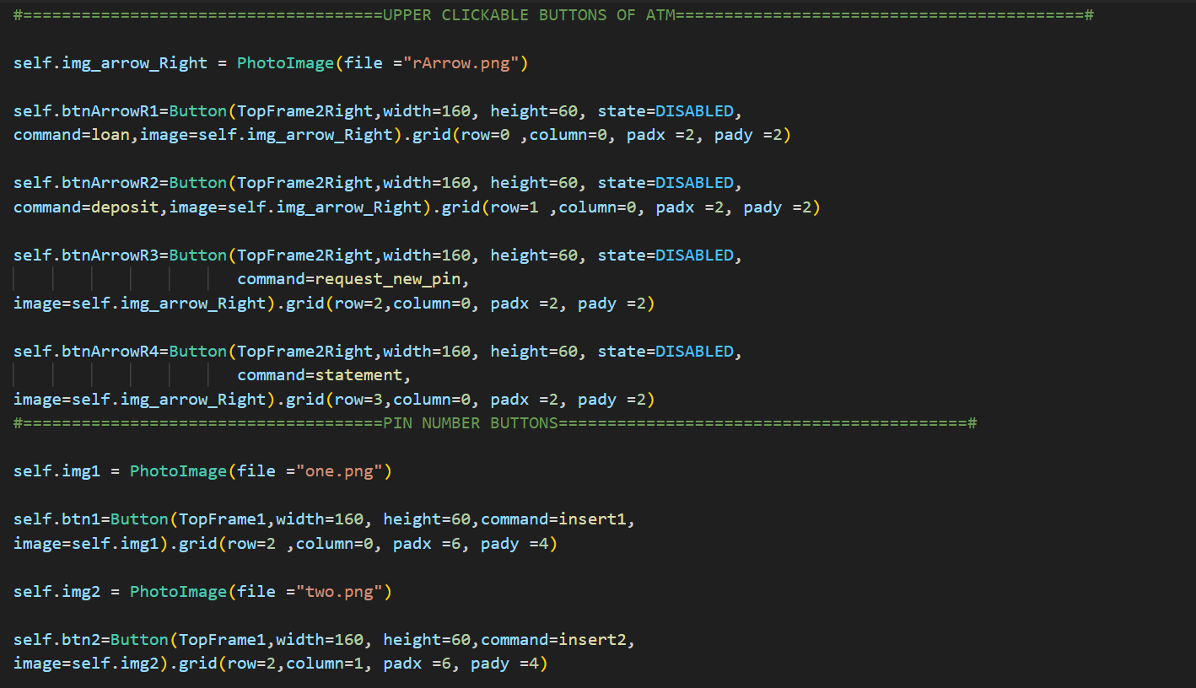

**End-**

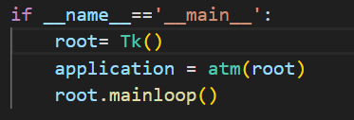

**Running Gui Window Automated Teller Machine-**

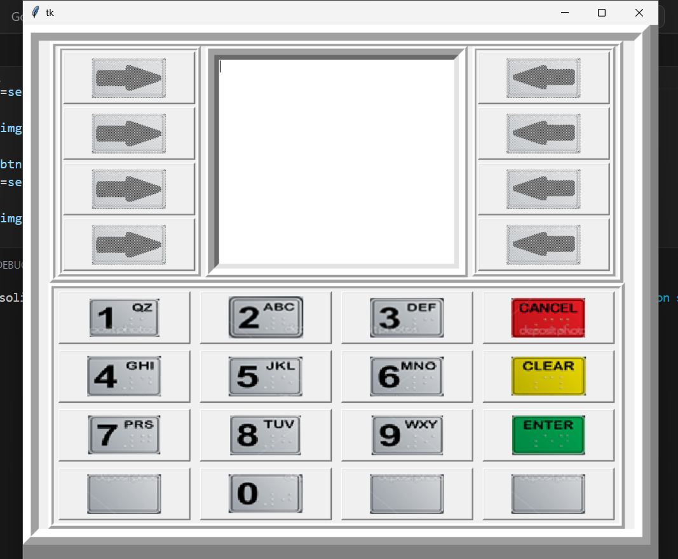

**Main Interface-**

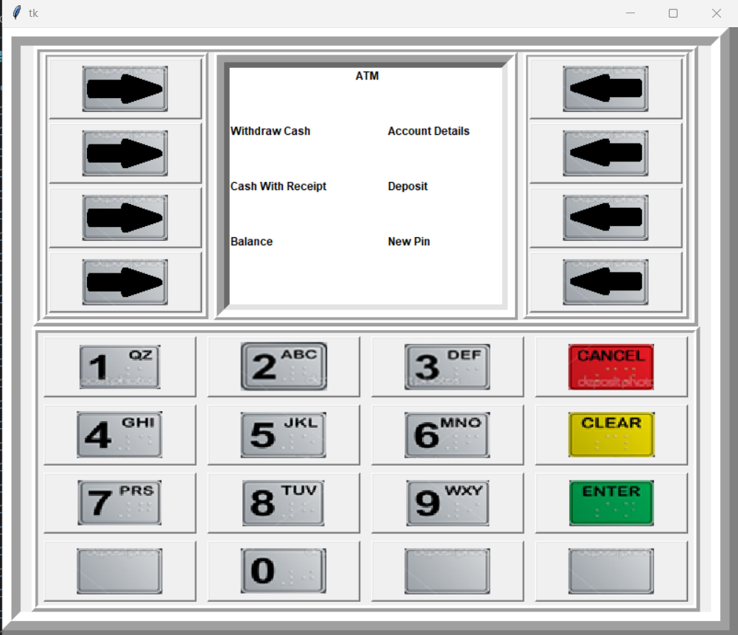

**Balance-**

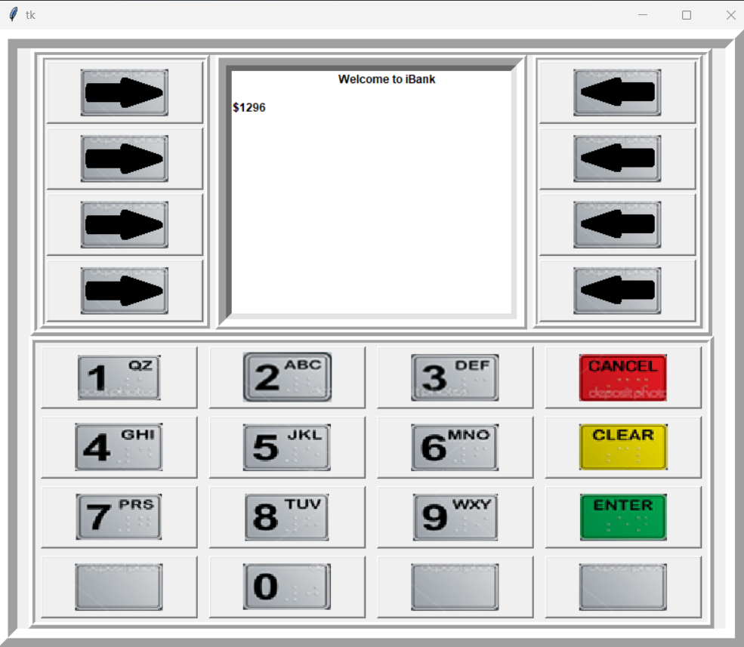

**Account Details-**

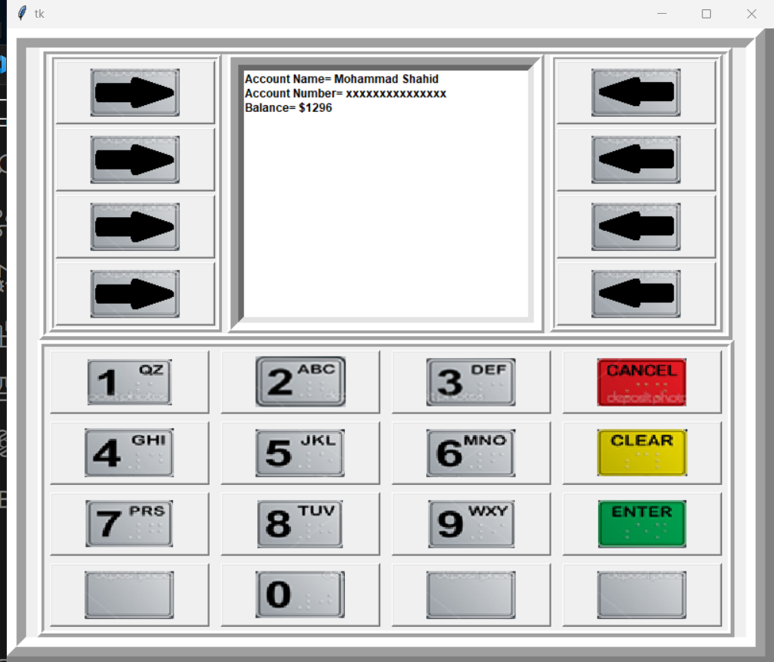

**Conclusion-**

Conclusion Automated Teller Machine, is a python Gui based programming where u can easily enter your pin and can check balance and withraw cash from atm,the process of making this project was interesting as well as knowledgeable